Rep of git hub = = https://github.com/Shivam-2807/tutedude

1. Creating and Renaming Files/Directories Command:

mkdir test_dir

cd test_dir

touch example.txt

mv example.txt renamed_example.txt

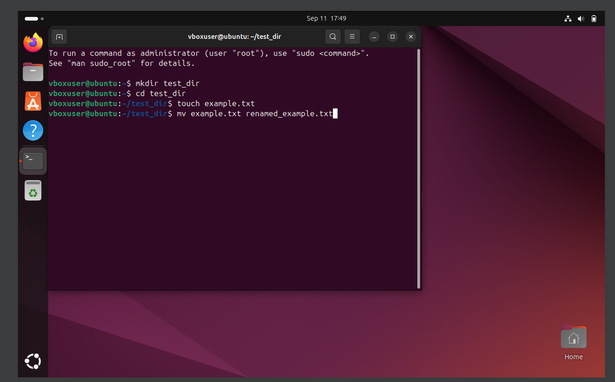

Explanation:

mkdir test_dir creates a new directory named test_dir.

touch example.txt creates an empty file inside it.

mv example.txt renamed_example.txt renames the file from example.txt to renamed_example.txt.

2. Viewing File Contents Command:

cat /etc/passwd

head -n 5 /etc/passwd

tail -n 5 /etc/passwd

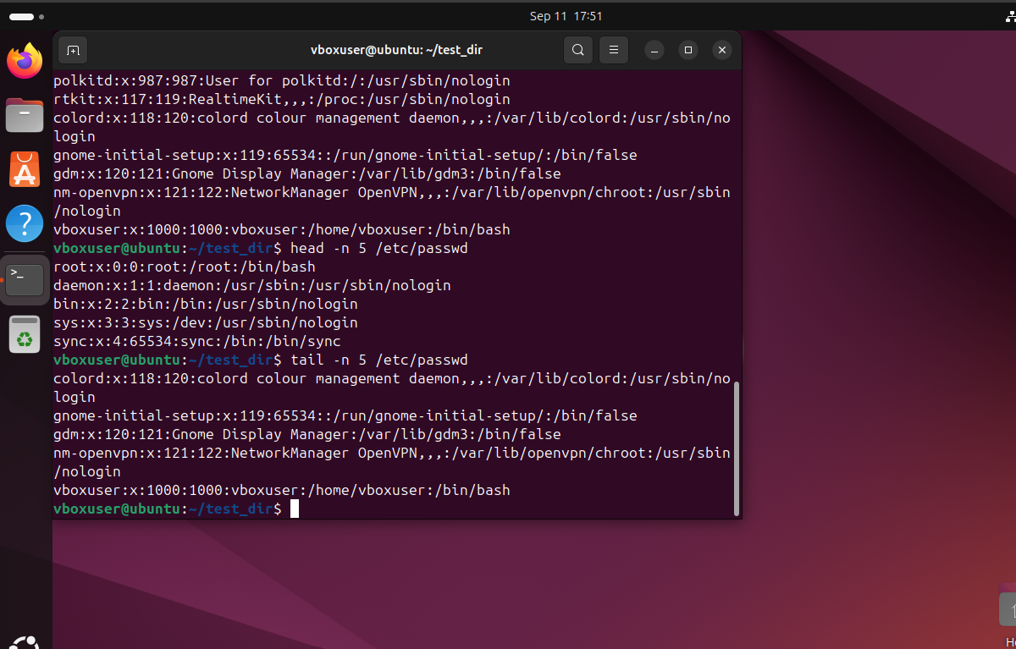

Explanation:

cat displays the full content of the file.

head -n 5 shows only the first 5 lines.

tail -n 5 shows only the last 5 lines.

3. Searching for Patterns Command:

grep "root" /etc/passwd

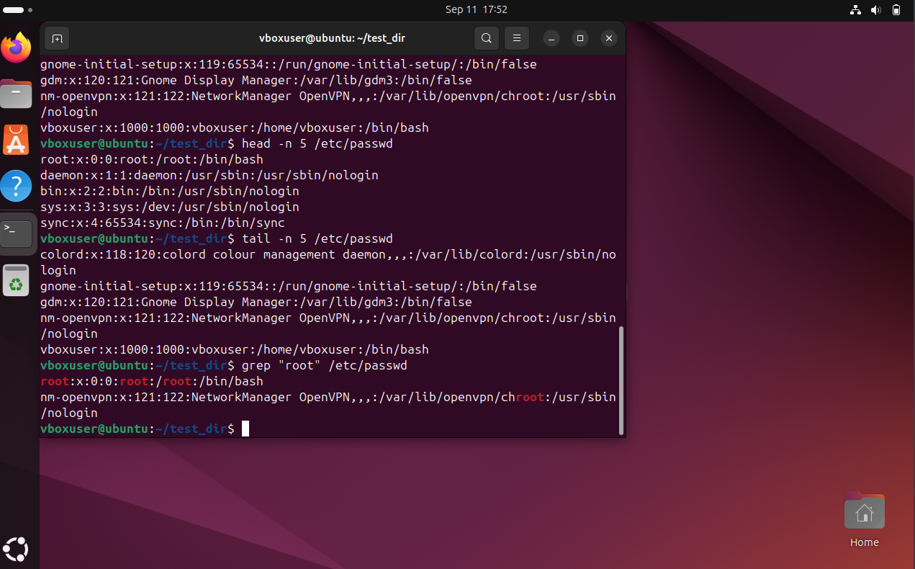

Explanation:

This searches the file /etc/passwd and displays only the lines that contain the word root.

4. Zipping and Unzipping Command:

cd ..

zip -r test_dir.zip test_dir

unzip test_dir.zip -d unzipped_dir

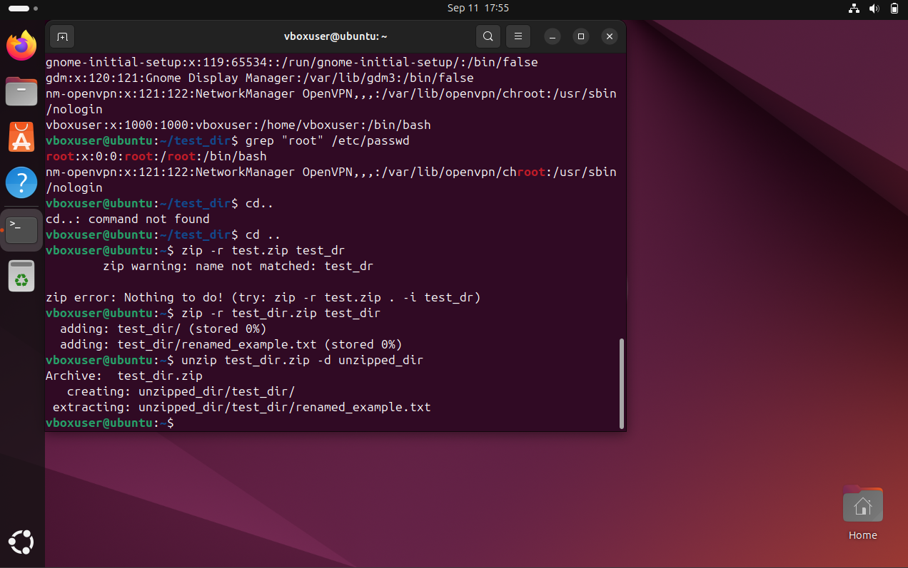

Explanation:

zip -r test_dir.zip test_dir compresses the test_dir folder into a zip file.

unzip test_dir.zip -d unzipped_dir extracts the contents of the zip file into a new folder named unzipped_dir.

5. Downloading Files Command:

wget https://example.com/sample.txt

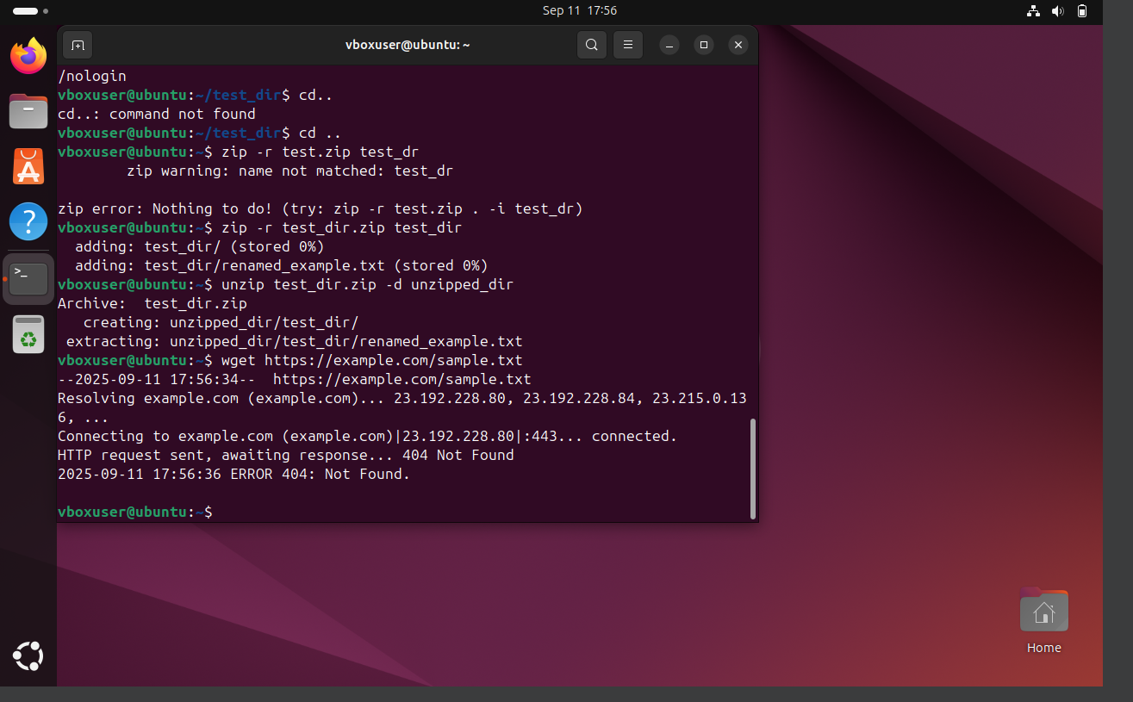

Explanation:

The wget command is used to download a file from the given URL and save it in the current directory.

6. Changing Permissions Command:

touch secure.txt

chmod 444 secure.txt

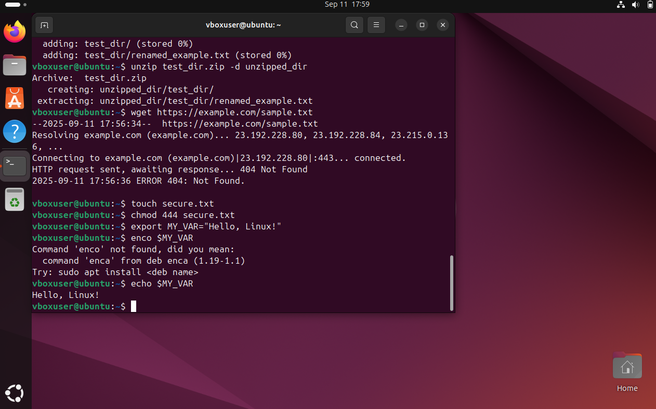

Explanation:

touch secure.txt creates a new empty file named secure.txt.

chmod 444 secure.txt changes the file permissions so that everyone can only read the file, but no one can write or execute it.

7. Working with Environment Variables Command:

export MY_VAR="Hello, Linux!"

echo $MY_VAR



Explanation:

export MY_VAR="Hello, Linux!" sets a new environment variable named MY_VAR.

echo $MY_VAR displays the value of that variable.